

**LIBRARY MANAGEMENT SOFTWARE**

**2017-2018**

**PROJECT REPORT**

***Submitted in partial fulfilment of the requirements for the award of***

**DIPLOMA**

**IN**

**COMPUTER ENGINEERING**

**Submitted By:**

***Lakshmendra Singh***

***Akshay Dubey***

***Hritick Goyal***

Under the supervision of

**Mr SALIM Istyaq**

ASSISTANT PROFESSOR

ELECTRICAL ENGINEERING SECTION  UNIVERSITY POLYTECHNIC (BOYS)

## ALIGARH MUSLIM UNIVERSITY

ALIGARH



University Polytechnic

Faculty Engineering & Technology

Aligarh Muslim University

**Certificate**

This is to certify that the work embodied in the project report entitled

“Billing system in JAVA” which is being submitted by Lakshmendra Singh, Akshay Dubey and Hritick Goyal in partial fulfilment of requirement for the awards of the “DIPLOMA IN COMPUTER ENGINEERING” of UNIVERSITY POLYTECHNIC, ALIGARH MUSLIM UNIVERSITY, ALIGARH.

This is a record of their cumulative effort carried out under my supervision and guidance. They completed this work unflagging zeal, interest and enthusiasm.

**Mr Salim Istyaq**

**(Assistant Professor)**

**University Polytechnic**

**A.M.U, Aligarh**

**ACKNOWLEDGEMENT**

With immense pleasure and great sense of satisfaction we acknowledge those without whom, the completion of this project couldn’t have been achieved. It is great privileges that I take this opportunity to express my heartfelt regards and gratitude to my teacher “Mr Salim Istyaq”, University Polytechnic, Aligarh Muslim University, Aligarh for his inspiring guidance, constant encouragement and help which was always forthcoming.

This affectionate attitude and constructive made this works easy and interesting

Lakshmendra Singh

(15-DPCE-166)

Akshay Dubey

(15-DPCE-171)

Hritick Goyal

(15-DPCE-183)

**ABSTRACT**

Library management system is a project which aims in developing a computerized system to maintain all the daily work of library .This project has many features which are generally not available in normal library management systems like facility of user login and admin login through which the admin can monitor the whole system. It provides an environment where student after logging in their accounts can see list of books issued and its issue date and return date. The librarian after logging into his account i.e. admin account can generate various reports such as student report, issue report and book report.

Overall this project of ours is being developed to help the students as well as staff of library to maintain the library in the best way possible and also reduce the human efforts.

**Contents**

1. Introduction
2. Need of Library management system
3. Hardware Used
4. Software used
5. Entity Relationship (E-R) Diagram
6. Data Flow Diagram (DFD)
7. Detailed description
8. Database
9. Skills used
10. Future Advancement
11. Reference

1. **Introduction**

* The project “Library management System” is an application to automate the process of issuing, returning, and maintaining records of books in a library. It reduces the risk of paper work such as file lost, file damaged and time consuming. It can help user to manage the transaction or record more effectively and timesaving.

* + This software named **Library Management System** will have following features-

* + 1. It will be able to issue books to students.
    2. It will be able to receive returned books from the students.
    3. It will maintain a record of books available in the library.
    4. It will also maintain the records of students and admin(s).
    5. It will also generate printed records of library statistics.

* + The proposed system either does not require paper work or very few paper works is required. All the data is feted into the computer immediately and various reports can be generated through computers. Since all the data is kept in a database no data of the library can be destroyed. Moreover work becomes very easy because there is no need to keep data on papers.

* + Computer operator control will be there and hence, no errors. Moreover storing and retrieving of information is easy. So work can be done speedily and in time.

1. **Need of Billing Systems**

* Avoids a lot paperwork in issuing books and keeping records.

* Performing automated calculations of fine and addition of new books.

**Six Major Benefits of Automation-**

The primary benefits of operations automation are:

**Cost reduction**,

**Instant updates**,

**Reduced paperwork**,

**Reduced wastage of time,**

**Accessibility**, and

**Performance**

**Cost reduction:**

Not having a **Library management** software can make tiny extra costs appear. You have to keep record of all details of books/students using a manual way that can cost you as well, as time is money. But with **Library management** software you can save it all in the system and in the software without having write it down and keep wasting money on pens and notebooks to keep everything recorded.

**Instant updates:**

**Library management** software updates you about all the issued books with records and adding new books to the Database as well. This way you remain updated about the books, students and the records remain under check. As the book issue happens the issued book get updated along with the required information about the student to which it is issued.

**Reduced paperwork:**

It helps you to reduce paperwork by keeping everything in soft form and only under few circumstances prints the statistics on the paper.

**Reduced wastage of time:**

Librarian is able to search record by using few clicks of mouse and few search keywords thus saving his valuable time.

# Accessibility:

The accessibility makes it simple for the librarian to get the updates anywhere and this way the librarian always has an eye on what is happening in the library.

# Performance:

The system is developed to cope up with the current issues and problems of library .The system can add user, validate user and is also bug free.

**3. Hardware Used**

Desktop/Laptop computer with following minimum requirements:-

* 2 GB RAM
* Intel Based processor
* Windows 7 OS or higher.
* Intel HD Graphics Driver or higher.



Computer System

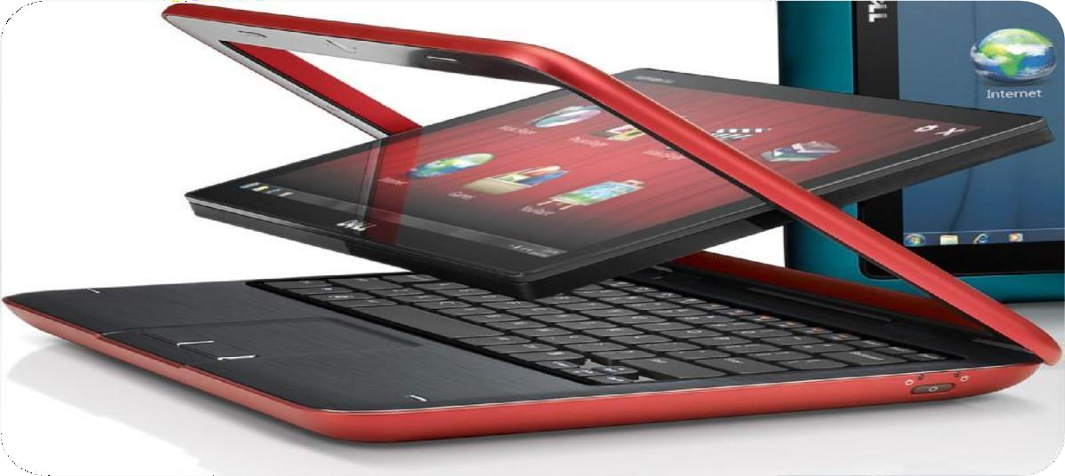

# Additional Hardware used:

➢ Printer

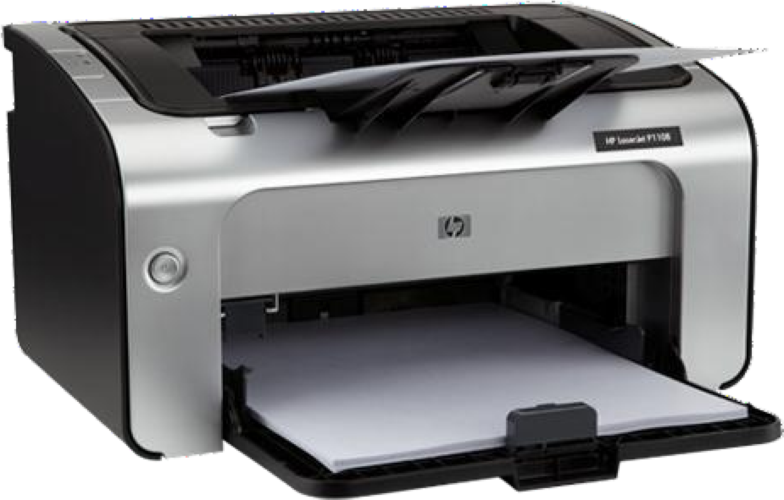

PRINTER

**4. Softwares/Applications used:**

1. Application – JAVA
2. Database – SQLite Manager
3. Languages used – JAVA
4. Development tools – NetBeans, JAVA Development Kit, Notepad++
5. Web Browser- Mozilla Firefox

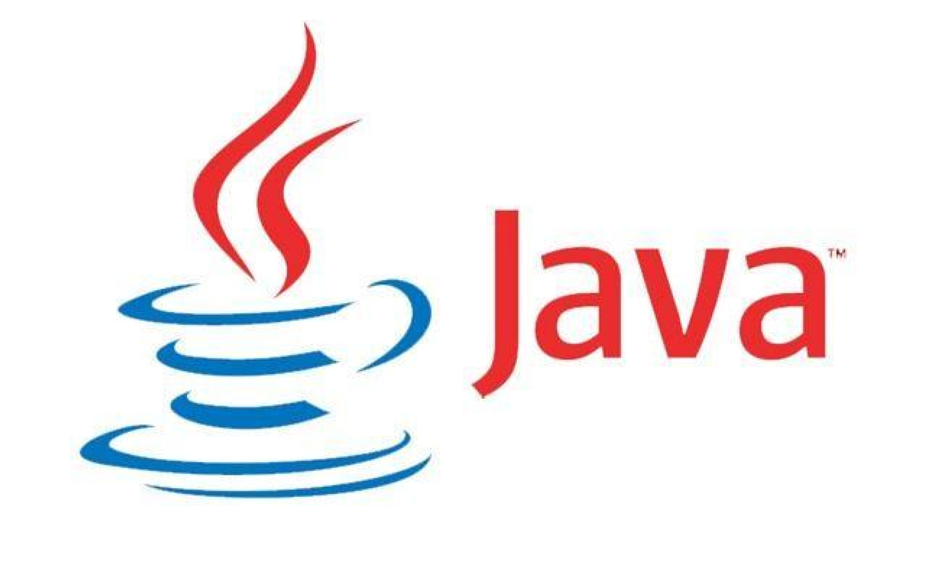

JAVA



NetBeans



**Mozilla Firefox**

SOFTWARE

**Front End**

1. Language used: JAVA

We use this language is supports event driven programming feature.

**Back end**

Supporting Software: SQLite Manager. This is used to storing data in the form of tables. It is easy to use.



SQLite Manager

**5. Entity Relationship (E-R) Diagram**

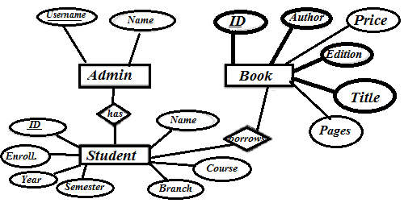

**6. Data Flow Diagram**

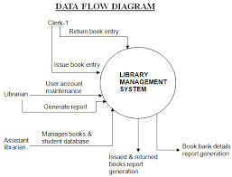

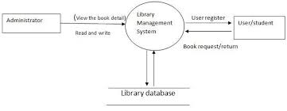

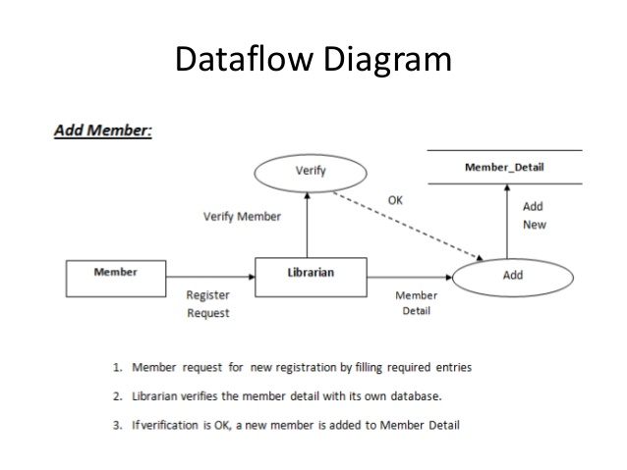

# 7. Library Management System Detailed Information

# (A) Login Page

This page is the first page on project start up. User enters his/her username and password and then this page directs the user to main menu through the loading page. However, if the username/password is incorrect then an error message is displayed showing the no. of attempts left. The user can also retrieve his/her password if forgotten by the method of security question.

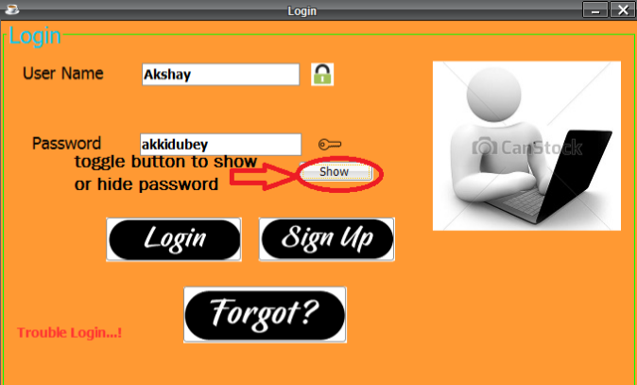

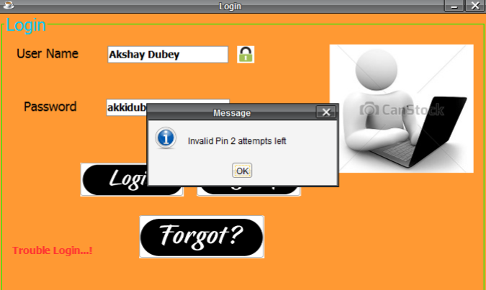

# (B) Account Recovery Page

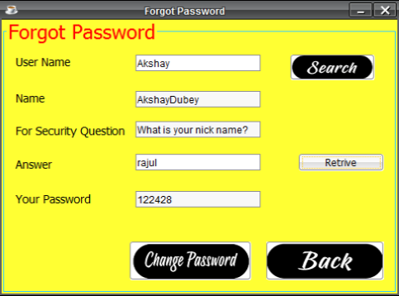

* This page lets the user to recover his/her account in case of forgotten password.
* The account can be recovered on the basis of a security question whose answer is already present in the database as entered by the user.
* The user needs to enter the username and click on the search button and all the fields related to that account are automatically retrieved from the database.
* The user needs to enter the correct answer to the security question for the retrieval of the account to be successful.
* The user can also change password if he/she desires.

# (C) Loading Page

* It is the in between page that connects login page to main menu.
* It supports animated gif and a progress bar to make it look attractive.

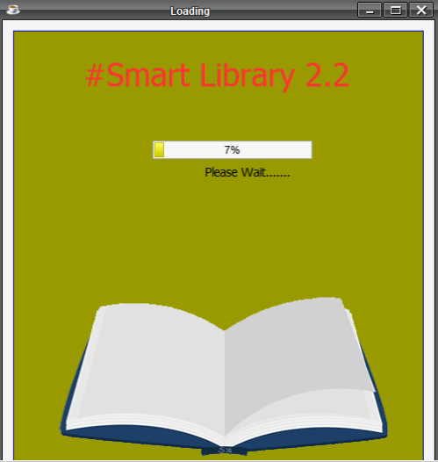

# (D)Main Menu

# There are several options for each link in the menu. These options are:-

* There are several options for each link in the menu. These options are:-
* File- Issue Book, Return Book, Renew, Close
* Edit- Student info, Book info, Account info
* Delete- Student, Book, Account
* View- Student Detail, Book Detail, Statistics, Account Details, Renew Details
* New Book- To add a new book into the database.
* New Student-To add new student into the database.
* Issue Book- To issue a book with a Student ID.
* Return Book-To receive book and calculate fine (if any).
* About- For information about the developers.

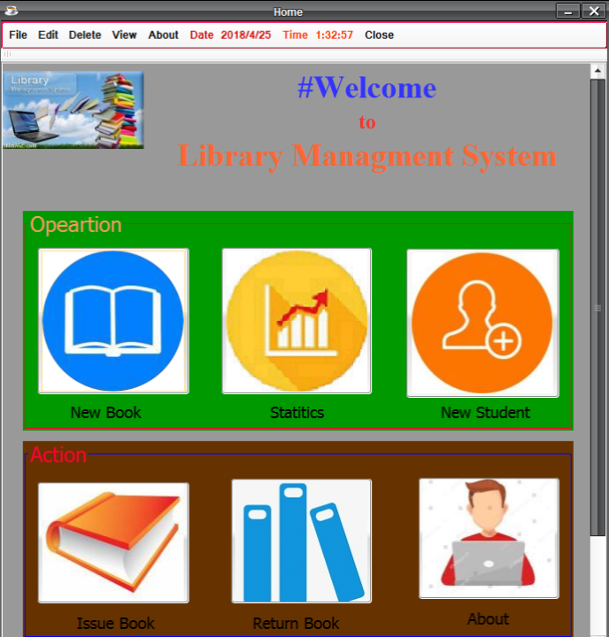

# (E)Add Account Page

* The new account page allows the user to add new account in database.
* User needs to enter the details in their corresponding fields.
* User can add a new account by pressing “Add” button.
* The user can also select the security question by dropdown list.
* User can also provide the image of the Account Holder.
* When the records are entered in database, a message displaying “Account Created” appears.

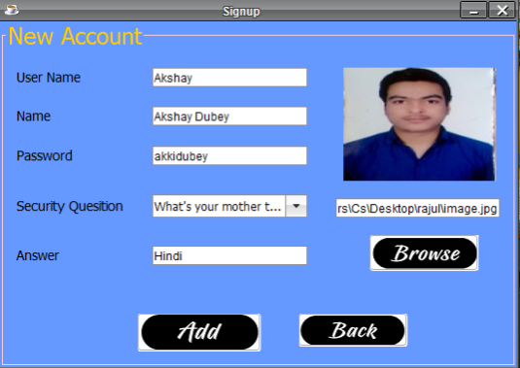

# (F) New Student Page

* The new student page allows the user to add new student in database.
* Student id field is generated randomly and other fields are provided by user.
* User can add a new student by pressing “Add” button.
* Year and Semester are provided by dropdown list.
* Student can provide his/her image also.
* When the records are entered in database, a message displaying “Student Added” appears.

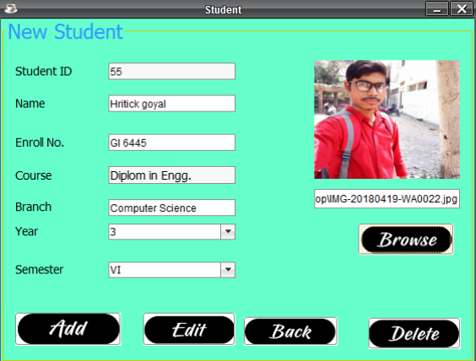

# (G)New Book Page

* The new book page allows the user to add new book in database.
* Book ID field is generated randomly and other fields are provided by user.
* User can add a new item by pressing “Add” button.
* The Edition of the book is provided by dropdown list.
* User can also provide the image of the book.
* When the records are entered in database, a message displaying “Book Added” appears.

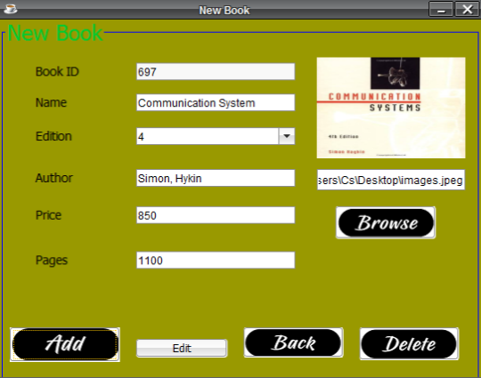

# (H) Statistics Page

* This page shows the statistics of the Database.
* It tells about the books that are currently issued and the students to which they are issued.
* User can search for the book/student by id, name, edition, Branch, price, pages, author, enrolment no. etc.
* The user can print the Library Statistics and even save the Statistics in the PDF form which increases the functionality.

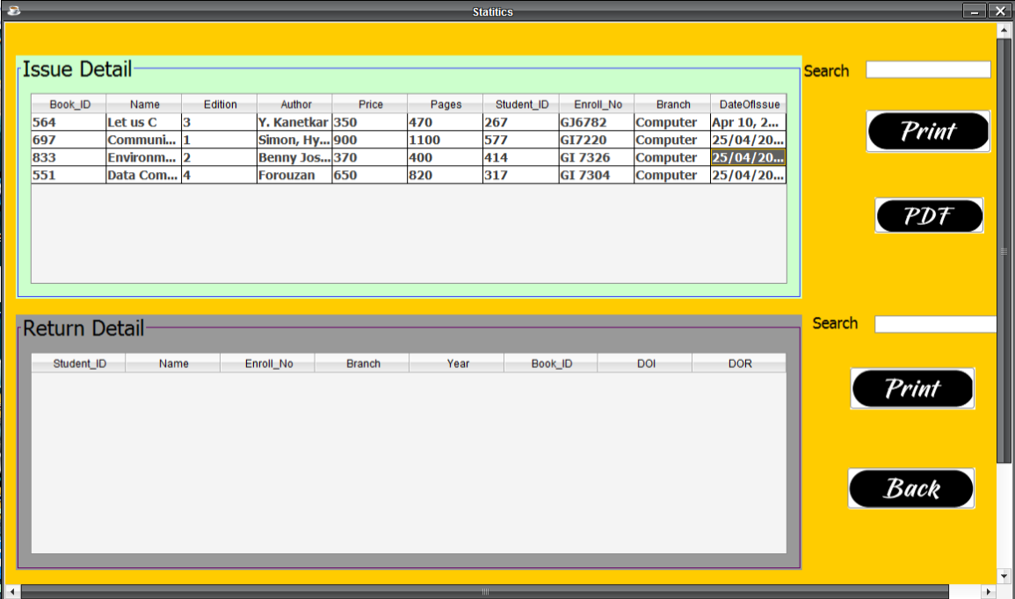

# (I) Issue Book Page

* This page lets the user to issue a book in the Database to a particular student present in the Database.
* The user needs to enter the Book ID and click on the search button and all the fields related to that book are automatically retrieved from the Database.
* The same case is with Student Detail.
* A Date Chooser is provided at the bottom to select the date of the issue of the book.
* When the user clicks on the “Issue” button, a confirmation message displaying “The Book has been issued” is displayed.

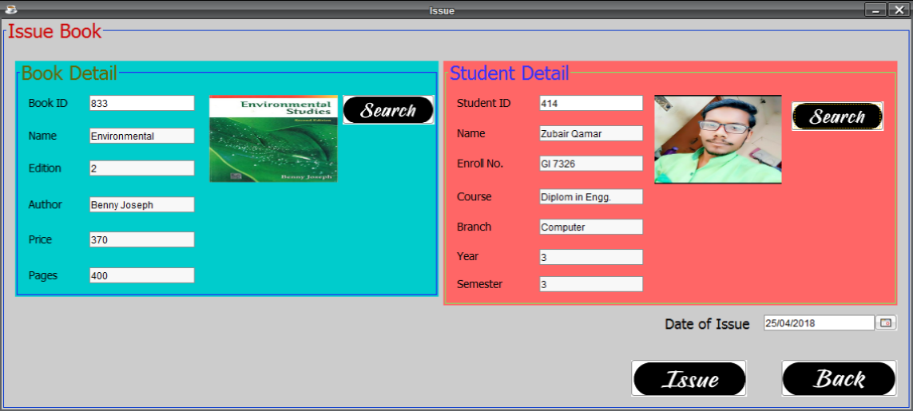

# (J) Return Book page

* This page lets the user to receive the returned book from a student
* The user needs to enter the Student ID and click on the search button and all the fields related to that student are automatically retrieved from the Database.
* The same case is with Books.
* A Date Chooser is provided at the bottom to select the date of return of book.
* Thereafter, the no. of days after book issue is calculated.
* Finally, the amount of fine in rupees (if any) is calculated based on the no. of days after issue.

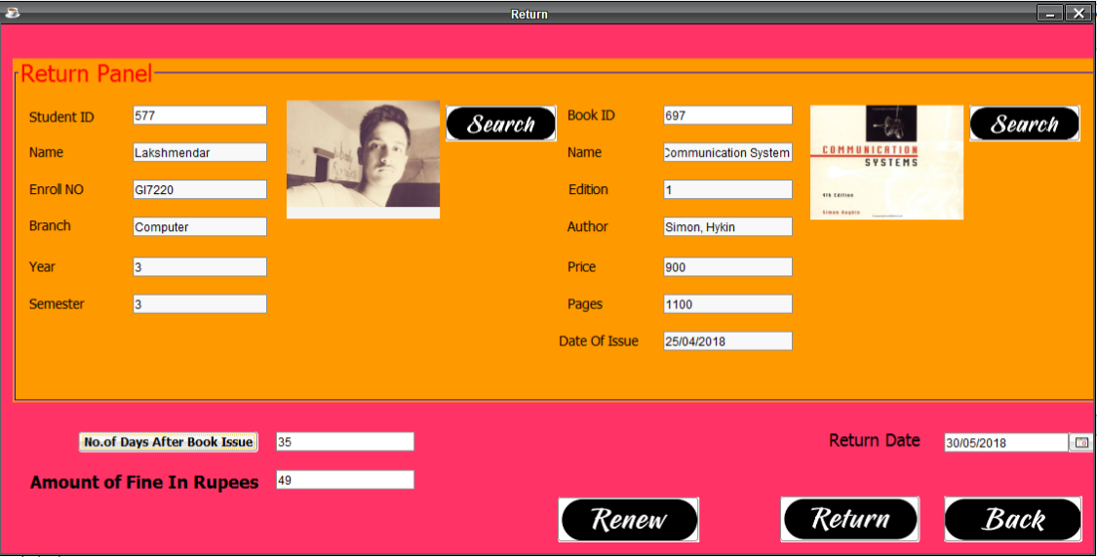

# (K) Renew Book Page

# 

* This page lets the user to renew the issued book for a student.
* The user needs to enter the Student ID and click on the search button and all the fields related to that student are automatically retrieved from the Database.
* The same case is with Books.
* A Date of Issue text field provide the Issue date when the book is first time issued.
* A Date Chooser is provided at the bottom to select the date of renew of book.
* After click on renew button the book is deleted from issue details.

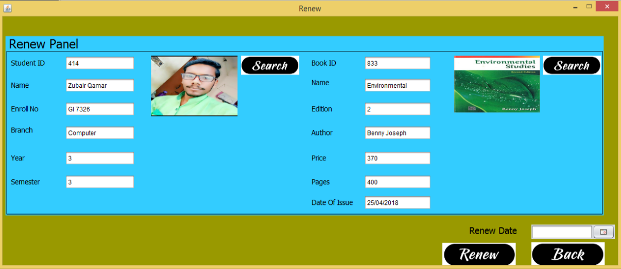

# (L) Edit Students Page

* This page enables the user to edit any student’s detail in the Database.
* The user needs to enter the Student ID and click on the search button and all the fields related to that student are automatically retrieved from the Database.
* User can edit the details by typing or by dropdown list.
* User can also update the image of a student.
* When the user clicks on the “Update” button, a confirmation message displaying “The Details have been updated” is displayed.

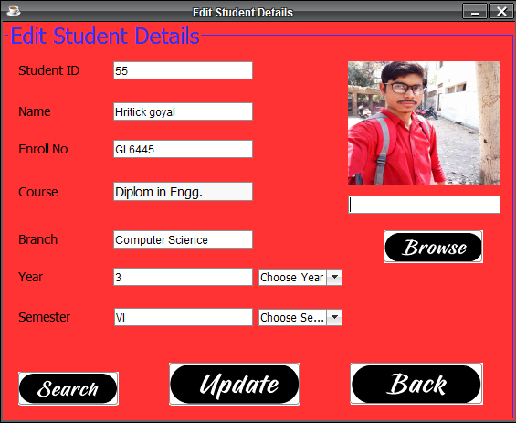

# (M) Edit Books Page

* This page enables the user to edit any book’s detail in the Database.
* The user needs to enter the Book ID and click on the search button and all the fields related to that book are automatically retrieved from the Database.
* User can edit the details by typing or by dropdown list.
* User can also update the image of the book.
* When the user clicks on the “Update” button, a confirmation message displaying “The Details have been updated” is displayed.

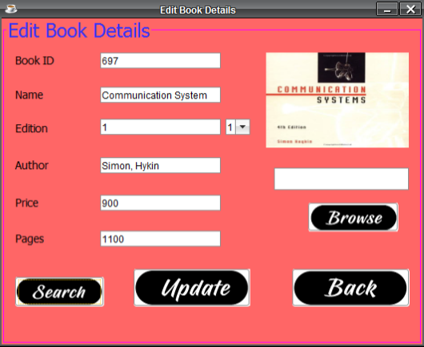

# (N) Edit Account Page

* This page enables the user to edit any Account’s detail in the Database.
* The user needs to enter the Username and click on the search button and all the fields related to that account are automatically retrieved from the Database.
* User can edit the details by typing or by dropdown list.
* User can also update the image of the account holder.
* When the user clicks on the “Update” button, a confirmation message displaying “The Details have been updated” is displayed.

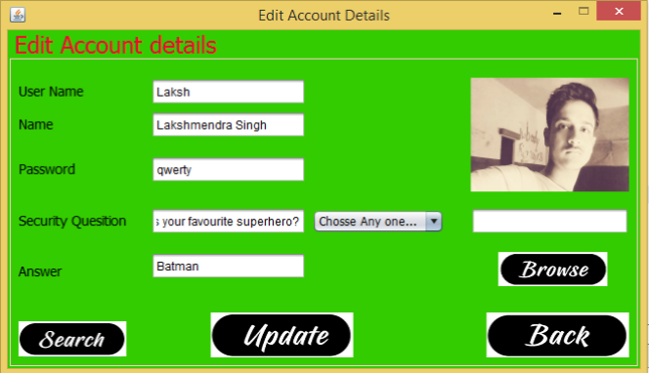

**(O)**  **Delete Student Page**

* This page enables the user to edit any Account’s detail in the Database.
* The user needs to enter the Username and click on the search button and all the fields related to that account are automatically retrieved from the Database.
* User can edit the details by typing or by dropdown list.
* User can also update the image of the account holder.
* When the user clicks on the “Update” button, a confirmation message displaying “The Details have been updated” is displayed.

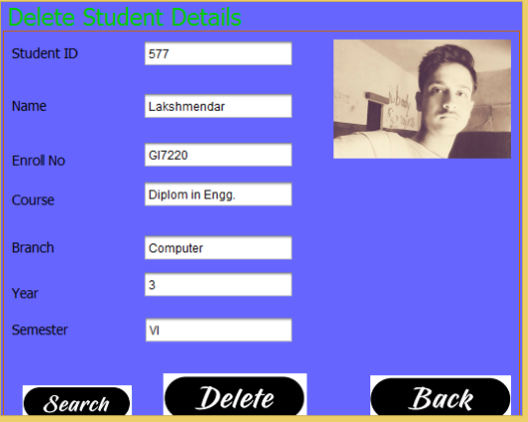

**(P) Delete Book Page**

* This page enables the user to edit any Account’s detail in the Database.
* The user needs to enter the Username and click on the search button and all the fields related to that account are automatically retrieved from the Database.
* User can edit the details by typing or by dropdown list.
* User can also update the image of the account holder.
* When the user clicks on the “Update” button, a confirmation message displaying “The Details have been updated” is displayed.

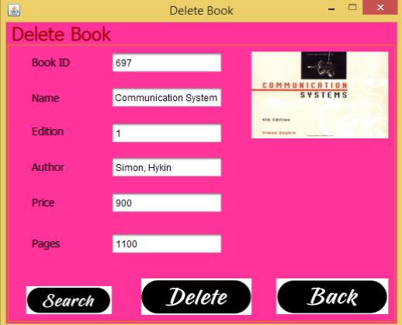

**(Q) Delete Account Page**

* This page enables the user to delete any Account from the Database.
* The user needs to enter the Username and click on the search button and all the fields related to that account including the image are automatically retrieved from the Database.
* When the user clicks on the “Delete” button, a confirmation message displaying “The Account has been deleted” is displayed.

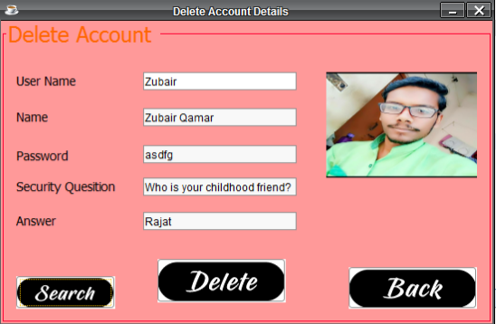

**(R) View Students Page**

* The View Students page provides description and details about the students present in the Database.
* These details include the Student id, Name, Enrolment No, Course, Branch, Year and Semester.
* It also shows the image of the student.
* The user can search by ID or any other field.
* The user can print the details of the Students and can also save these details in the form of PDF file.

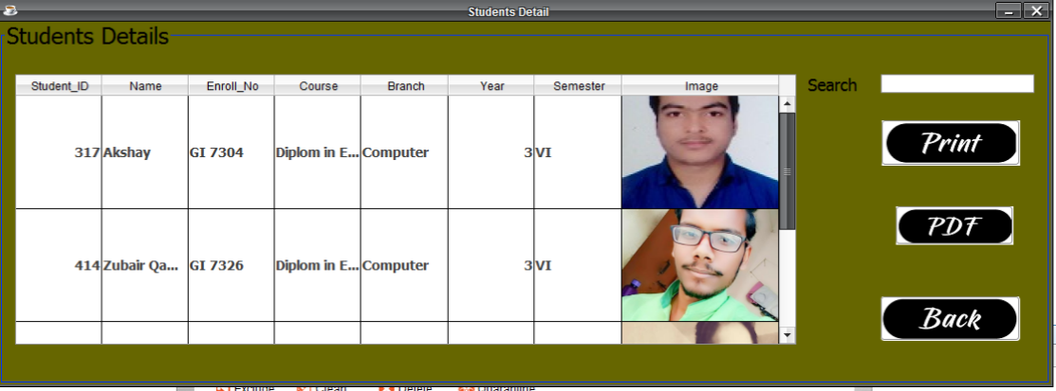

**(S) View Books Page**

* The View Books page provides description and details about the books present in the Database.
* These details include the Book id, Name, Edition, Author, Price and Pages.
* It also shows the image of the book.
* The user can search by ID or any other field.
* The user can print the details of the Books and can also save these details in the form of PDF file.

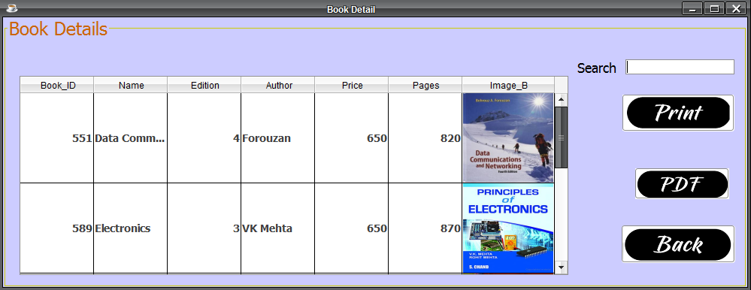

**(T) View Accounts Page**

* The View Accounts page provides description and details about the User Accounts present in the Database.
* These details include the Username, Name, Security Question and Answer.
* It also shows the image of the Account Holder.
* The user can search by ID or any other field.
* The user can print the details of the Account and can also save these details in the form of PDF file.

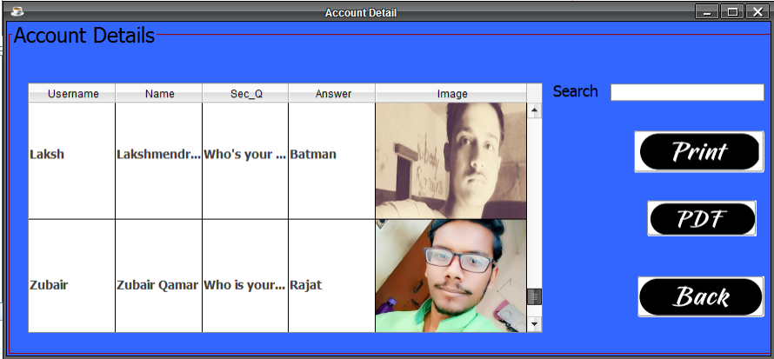

**(U) About the Developers Page**

* This page tells about the developers, version and other details about the project.

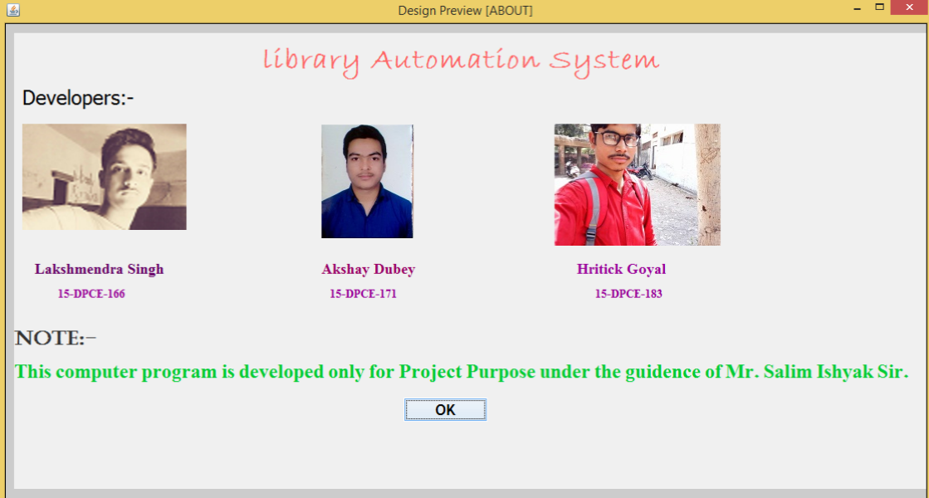

**8. Database**

**Tables**

* **Account**
* **Book**
* **IssueB**
* **Renew**
* **Return**
* **Student**

**1. Account**

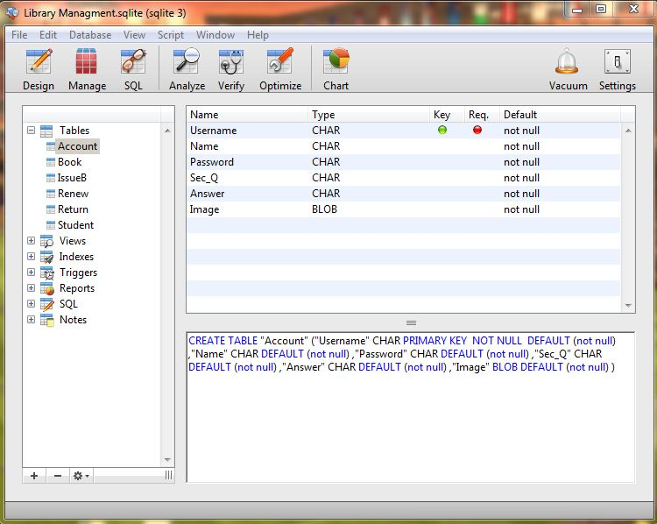

**2. Book**

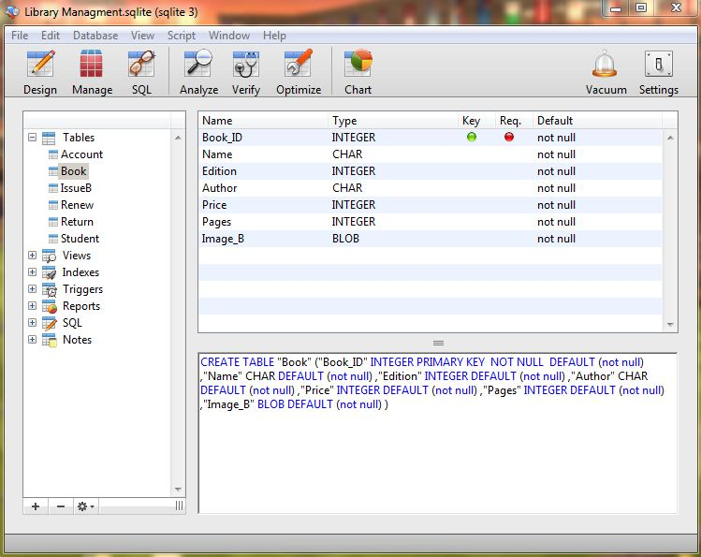

**3. IssueB**

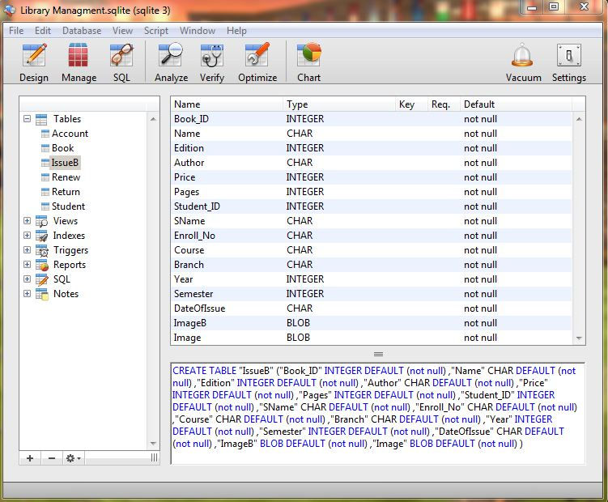

**4. Renew**

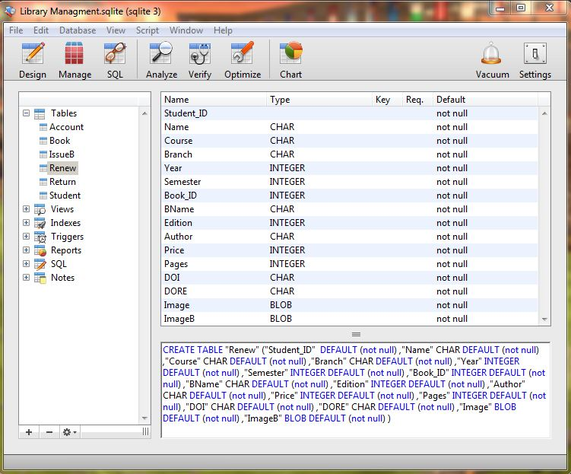

**5. Return**

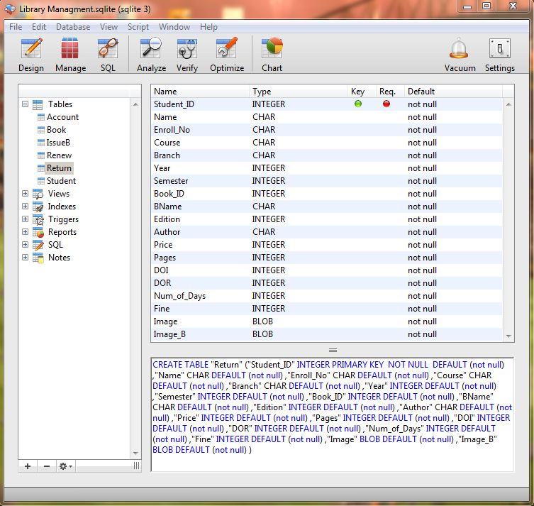

**6. Student**

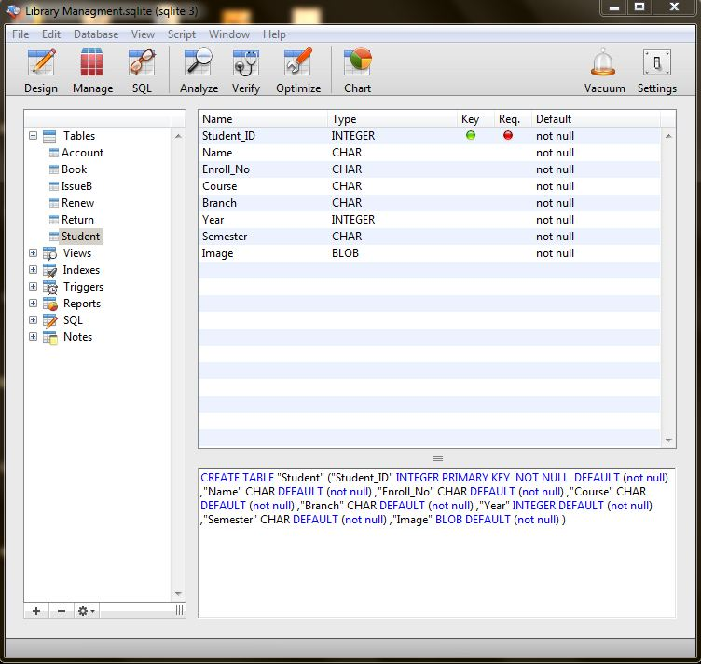

**9. Skills used**

* 1. Hardware
  2. Programming
  3. App designing on Netbeans.
  4. JAVA APP development using JDK.
  5. Database development on SQLite Manager.

**10. Its Future Advancement**

* 1. The Library Management System can be developed for online purposes in future
  2. In the online version, the front end will be HTML, CSS based.
  3. The middle part will be JAVA based.
  4. And the rear end will be SQLite based.

**11. References**

* + **www.google.co.in**
  + **www.wikipedia.org**
  + **www.youtube.com**
  + **www.oracle.com**
  + **www.javatutorialpoints.com**
  + **www.javatpoint.com**
  + **www.w3schools.com**